Circuit Diagrams
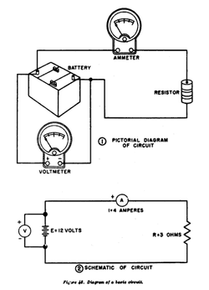
Look at this circuit diagram.
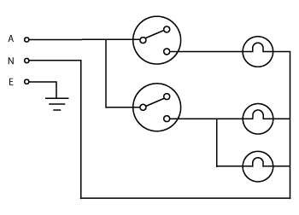
Questions.
How many switches does this circuit have?
How many light globes does this circuit have?
What is the voltage of the power source?
How many voltmeters does this circuit have?
Draw the circuit below using a circuit diagram into the space beside it.
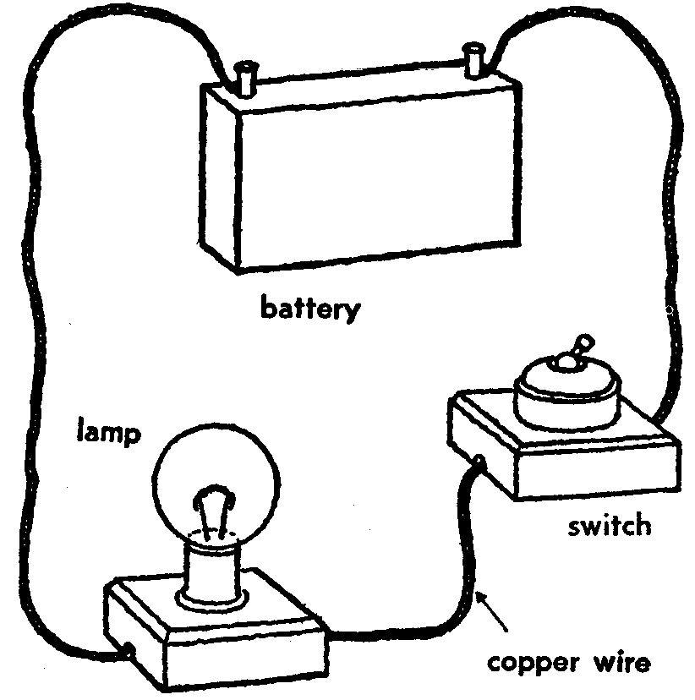

Now draw the circuits around the room into the boxes below.
Circuit A | Circuit B
Circuit C | Circuit D

